Press Release
Fraunhofer IMS develops extremely low-noise read out-ASIC for capacitive sensors
Extremely low-noise, highly precise: Those are the prominent characteristics of the »IMS-CAP51«.
The new IMS-CAP51 adds these »merits« to the read-out of capacitive sensors, for example of acceleration-MEMS. Its special talents come into effect where highly accurate measured data is of great importance: for example seismic measurements for the early detection of earthquakes. The fundamental mode of operation: The IMS-CAP51 of the Fraunhofer Institute for Microelectronic Circuits and Systems IMS is connected to a capacitive acceleration- MEMS (Micro Electronic Mechanical System) on a printed circuit board. Acceleration forces affect this MEMS, which hence generates a capacity- gap. The ASIC converts the measured capacity-gap into voltage. Eventually, this voltage is translated into a digital measurement-value by an analog to digital-converter. The ASIC can be delivered with an analog-digital-converter if requested.

What is special about this new development from the business unit »ASICs« of the Fraunhofer IMS?
»The core task was to develop a read-out circuit where the input-based noise is extremely low« describes Dr.-Eng. Alexander Utz, head of the project ASIC-development, the initial situation. Because: the higher the noise, the less reliable the measurement results. The task is solved after two years of time. The Fraunhofer-Team has achieved a very low input-based noise- with a concurring broad range (0 Hz- 15 kHz). The input-based noise is located at values beneath 50 zF/rt-Hz- therefore the new IMS-CAP51 of the Fraunhofer IMS from Duisburg holds the world-record!
Those results were obtained by the experts by executing the capacity-voltage conversion as a AC-paired Chopper-amplifier. »With this method, the 1/f-noise, which is dominant at semi-conductor circuits and is especially disruptive at lower frequencies, can be confined, respectively suppressed effectively«, explains Dr.-Eng. Alexander Utz.
Now the ASIC can be applied where especially delicate measurements with weak signals have to be carried out. Customer-specific realizations for special requirements are gladly implemented by the Fraunhofer IMS in accordance with the customer. This opens up diverse application fields. Applied in early-detection systems for earthquakes or Tsunamis it can supply information about vibrations in the earth early and precisely. Such seismic measurements are also helpful to the search of oil-and gas fields. Vibration profiles are recorded, which allow conclusions about potential oil-and gas resources. The ASIC can also be applied to measure vibration in course of monitoring building foundations. In connection with a positioning-sensor the ASIC can also be utilized for the alignment of antennas- by using the effects of earth’s gravity onto the sensor.

Fraunhofer IMS
For 30 years, scientists at the Fraunhofer IMS in Duisburg have occupied themselves with the development of microelectronic circuits, electronic systems, micro-systems and sensors. Based on its broad Know-how, access to technologies and high-end development-services, the institute is a world-wide recognized partner for the industry. The Fraunhofer IMS dedicates itself to applied research, the pre-development for products and their applications in eight business units. Stabile, efficient and marketable technologies and procedures, which are utilized in many branches, are always at the core of its commissional work.

Pictures and Captures

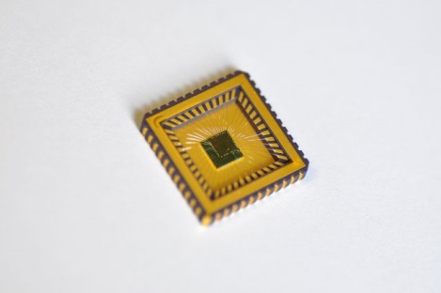
©Fraunhofer IMS

Developed at the Fraunhofer IMS »IMS-CAP51" mounted in a ceramic package PLCC44

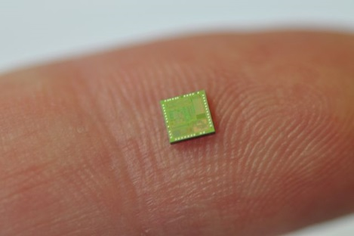
©Fraunhofer IMS

Proportion: The "IMS-CAP51" sensor on a fingertip

Dieses Feld, sowie die Tabelle auf der letzten Seite nicht löschen!

