Press information
Multi-sensor for the optimization of bio processes

A sensor system for simultaneous in-situ monitoring of glucose, lactate, cell density and pH-value allows a cost-effective acquisition of important parameters in bio processes and an increase of efficiency and safety.

Scientists at the Fraunhofer Institute for Microelectronic Circuits and Systems IMS have successfully integrated a miniaturized multi-sensor system for the in-situ monitoring of bio-processes onto a silicon chip. The system combines sensors for glucose, lactate, cell density and pH-value on a chip surface of 7 mm x 7 mm. Thus parallel measurement of these four process variables in-situ, therefore directly within the bioreactor, is possible for the first time with especially wide measuring ranges for glucose and lactate. Compared to previously customary single-chips in biotechnology, the sensor chip requires less space, does not need elaborate sampling from the reactor, and is easier and more cost-efficient in utilization and easier to be sterilized. The sensors can be manufactured on CMOS-chips and this way be combined with circuits for read-out and transmission of measured data. Due to the real-time measurement of relevant process parameters the developed system has the potential to manufacture a broad spectrum of biotechnological products more efficiently, enhance the product safety and to support the development of new drugs. The wide measuring range for glucose (1 mM up to 600 mM) and lactate (1 mM up to 900 mM), which is achieved without dilution or further pre-treatment of the probe, distinctly exceeds other solutions available on the market. Applications of the system range from fermentation processes for the manufacturing of alcohol to the production of antibodies, insulin or vaccines to cell cultures for the cultivation of tissue. Especially complex processes, for which numerous parameters must be optimal adjusted and monitored, can profit from this development of the Fraunhofer IMS. Stefan Mross, researcher in the business unit Biohybrid Systems, points out the advantages of the multi-sensor system: »A continuous measurement of relevant process parameters in biotechnological production processes can decisively enhance the level of automation, the process yield and quality«.
Integrated read-out and radio transmission
Integrated circuits for read-out and transmission of measurement data are developed at the Fraunhofer IMS. Hence a newly developed potentiostat is available for read-out of glucose and lactate sensors, which, due to a transponder chip, not only captures the data but is also capable of transmitting to a receiving station via radio communication. The wireless operating simplifies the application in biotechnological facilities and offers interesting possibilities for other branches which depend on mobile, flexible sensors, such as medical engineering and sports medicine.
The Fraunhofer IMS offers customer-specific solutions: The system can be adapted to customer’s requirements, additional sensors can be integrated or read-out circuits can be offered separately or developed further. Hence the supply addresses itself to sensor manufacturers, operators of bioreactors as well as the food and chemical industry besides the manufacturers of biomedicine.
Fraunhofer IMS
For 30 years, scientists at the Fraunhofer IMS in Duisburg have occupied themselves with the development of microelectronic circuits, electronic systems, micro-systems and sensors. Based on its broad Kknow-how, access to technologies and high-end development services, the institute is a world-wide recognized partner for the industry. The Fraunhofer IMS dedicates itself to applied research, the pre-development for products and their applications in eight business units. Stable, efficient and marketable technologies and procedures, which are utilized in many branches, are always at the core of its commissional work.
www.ims.fraunhofer.de

Pictures and Captions
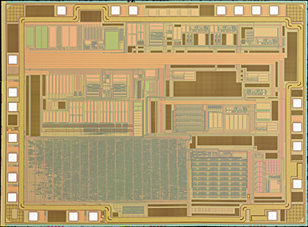
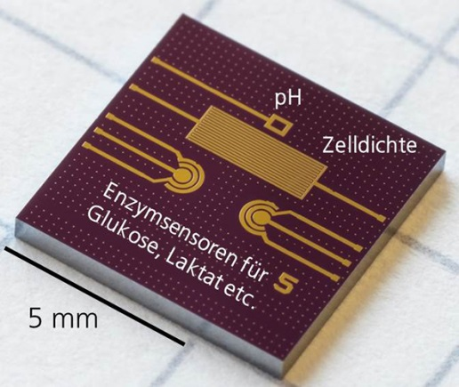

Nanopotentiostat
© Fraunhofer IMS
Multi-sensor chip
© Fraunhofer IMS

Dieses Feld, sowie die Tabelle auf der letzten Seite nicht löschen!

