Press Release
Fraunhofer IMS develops RFID-based fire protection for electrical cabinets

Electrical cabinets are used in every industrial manufacturing plant; they serve the supply, control and regulation of machinery and other plant components and are therefore indispensable for industrial processes. According to statistics of the German Insurance Association GDV, 30 percent of all fires are caused nationwide by defects of electrical plants or devices. The fact, that a potential fire can spread rapidly via the wiring located in electrical cabinets is highly hazardous. Hence fire protection for electrical facilities is of high importance. However, fire protection for facilities and devices cannot be sustained or covered completely solely with regulations and safety notes as determined by national/international standards (e.g. DIN or ISO).
One of the most important measures for fire protection is early detection. That is what the »Electrical Cabinet Monitoring« of the Fraunhofer Institute for Microelectronic Circuits and Systems IMS from Duisburg guarantees. Employees of the business unit »Wireless Transponder Systems« have utilized their experience of many years in the field of wireless communication and energy supply and have developed a RFID-based solution for the fire protection in electrical cabinets. Therefore researchers of the Fraunhofer IMS conducted analyses of the field distribution in electrical cabinets. A particular antennae- concept enables the assembly of transponders directly onto the metal conductor rails of an electrical cabinet. Multiple reader antennas are arranged properly in the electrical cabinet, so the read-out of a transponder is possible at every required position. By applying wireless temperature-transponders, no wiring to the point of measurement is necessary. Because of this antennae arrangement, 60 or more transponders can be operated in one single electrical cabinet. »With our solution, the remote monitoring of electrical contacts in electrical cabinets is possible. Hence malfunctions and fires in electrical cabinets can, to a great extant, be prevented«, summons Andreas Henning, team leader of »Wireless Sensor Technology« at the Fraunhofer IMS, up.
The transponders operate without batteries and are supplied by a reader with the needed energy. Reader and transponders operate within a frequency range of 866 MHZ and reach a read-range of up to one meter. The data, which the transponders supply, can be transferred by a reader connected to Pc or Tablet to the internet and evaluated there. » Our sensor-transponders can certainly be operated in other industrial facilities where components, such as bearings and pumps, can overheat and cause fires due to attrition or malfunction«, explains Andreas Henning.

Fraunhofer IMS

For 30 years, scientists at the Fraunhofer IMS in Duisburg have occupied themselves with the development of microelectronic circuits, electronic systems, micro-systems and sensors. Based on its broad Know-how, access to technologies and high-end development-services, the institute is a world-wide recognized partner for the industry. The Fraunhofer IMS dedicates itself to applied research, the pre-development for products and their applications in eight business units. Stabile, efficient and marketable technologies and procedures, which are utilized in many branches, are always at the core of its commissional work.

Pictures and Captures
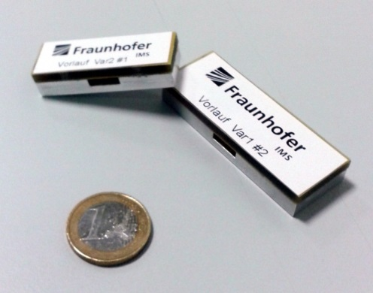
Transponder compared in seize to a Euro-coin
®Fraunhofer IMS
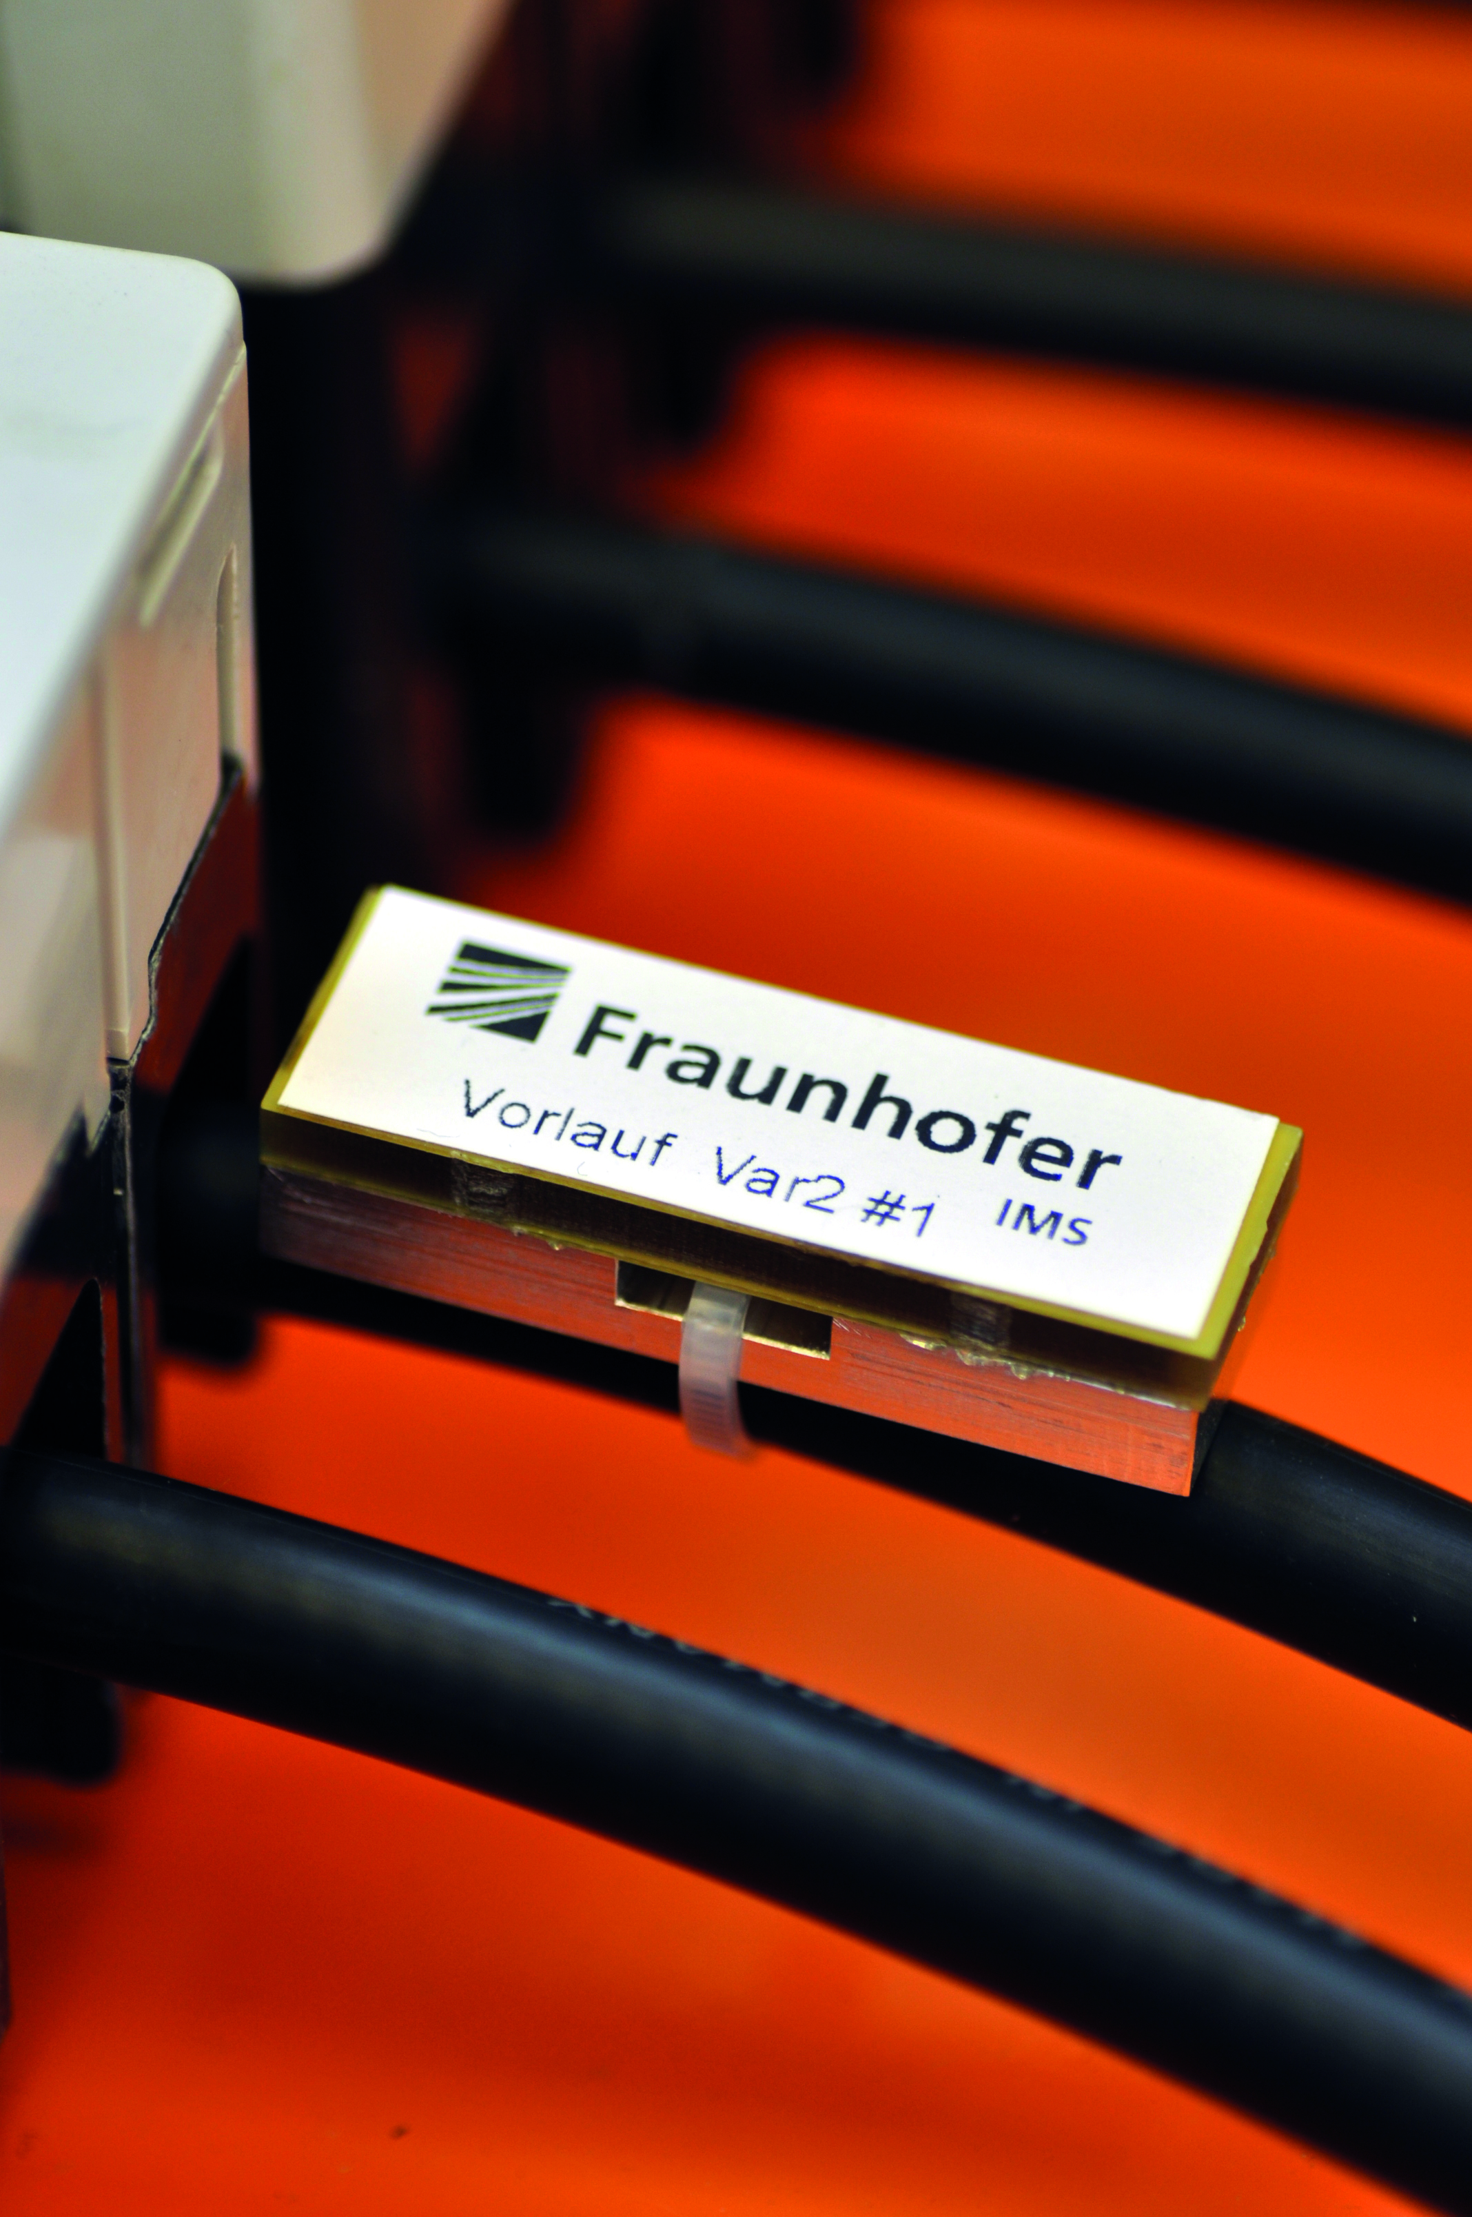
Assembled transponder
®Fraunhofer IMS
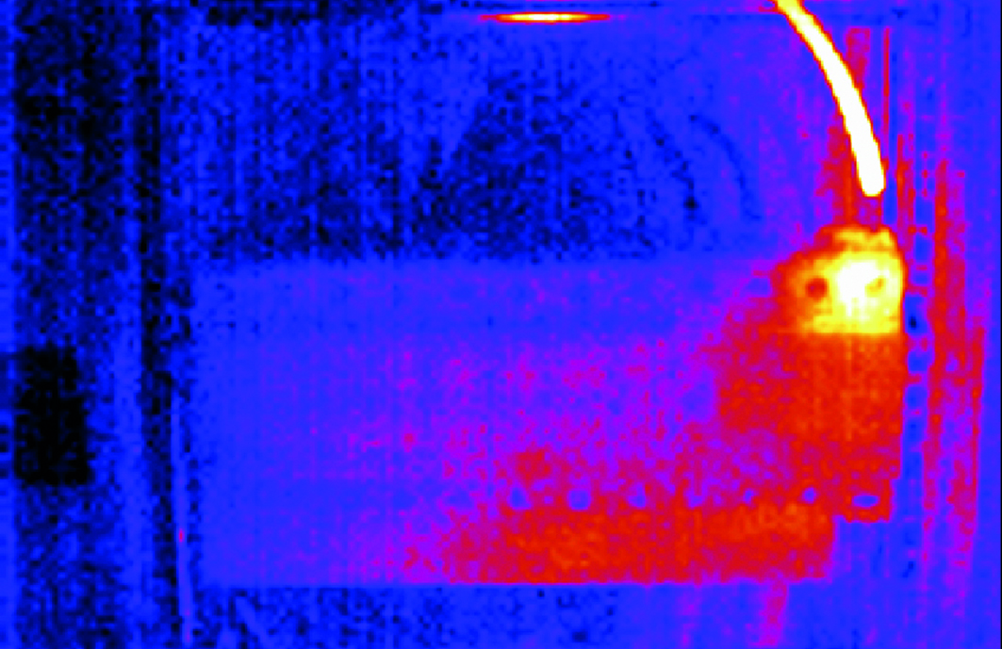
Thermography unwanted heat generation in a control cabinet
®Fraunhofer IMS
Dieses Feld, sowie die Tabelle auf der letzten Seite nicht löschen!

