Press Release

Strengthen the location, develop technology,
shape the future
In the new “Research factory Microelectronics Germany“ Institutes of the Fraunhofer-Gesellschaft and the Leibniz-Gesellschaft bring together their expertise to strengthen and further expand the technology location Germany in micro and nanoelectronics in common. The Fraunhofer IMS from Duisburg is part of this cross-location technology pool.

She is the key industry of the present day. Her products have already become integral components of everyday life, without them no smartphones or PCs would exist. Especially in commission of the progressing digital transformation all relevant industry branches are going to be more and more dependent on her: the micro and nanoelectronics. Driven by the World Wide Web real and virtual worlds grow together as an “Internet of things” (short: “IoT”) which takes already now a center role for the mega trends of the future, like industry 4.0, energy, mobility, health and living. Tiny, intelligent linked sensors are on the advance, so that market research and consulting companies assume that until the year 2020 far more than 25 billion devices are going to be connected to the internet of things. In the micro and nanoelectronics the minimization of chip-structures (“More Moore”) semi conductors with more features on a chip get an increased significance. These requirements are in particular supported through so-called “More than Moore”-technology that enables the integration of many features on one micro chip. This development is especially important for the German and European industry because through them enormous growth chances for the industry sectors like mechanical and plant engineering, automation and energy technology, automobile manufacture and medical technology occur.
Whoever wants to win the race about this technology, most of all needs to invest into the microelectronics. But in hardly any other technology branch the worldwide competition is as challenging as in electronic systems.
In the framework of the new technology pool “Research factory Microelectronics Germany“ initially eleven Institutes of the Fraunhofer Alliance Microelectronics (IMS, EMFT, ENAS, FHR, HHI, IAF, IIS, IISB, IPMS, ISIT, IZM) as well as two Liebniz-Institutes (IHP and FBH) bring together their expertise to achieve together a new quality in research, development and (pilot) fabrication of semiconductor based micro and nanoelectronics and further expand them.
Due to the consistent merger of know-hows the technology sovereignty and the attractiveness of the location Germany should be sustainably and long-term strengthened.
The promotion of the German Federal Ministry of Education and Research deals with an accompanying measure for the – on European level requested – “Important Project of Common European Interest” (IPCEI) for microelectronics, in which the Federal Ministry for economic affairs and energy wants to toughen up the German semiconductor industry for the next product generations with 1 billion euros. While the IPCEI is focused on industrial product capacity building, the Fraunhofer-Gesellschaft is going to allocate the accompanying research and development in cooperation with the Leibniz alliance and the help of the “Research factory Microelectronics Germany“. The federal research ministry supports for this purpose the necessary investments in the next years with about 280 million euros for Fraunhofer. The research factory is organized in four cross-location technology parks that deal with the respective subject specific focal points of research and complement each other: “Silicon-based technology”, “compound semiconductors and special substrates”, “heterointegration” and “design, test and reliability”. Each involved institute is assigned to at least one technology park. Due to the connection of skills and competences of the individual institutes, an efficient coordinated work and for the first time common research and development over multiple locations becomes possible.

New machines for the Fraunhofer IMS in Duisburg
The Fraunhofer-Institute for microelectronic circuits and systems IMS receives about 26 million euros of the funding amount. The money is going to be invested especially in new machines and the structural composition within the research factory. “To sustainably establish us in microsystem technology, we want to intensify our research on intelligent sensor chips and compile novel components”, says Prof. Holger Vogt, representative institute director and leader of the department “Front-end microsystem technology”. “Due to for example new separation and etching processes that are going to be possible with the acquired new machinery within the manufacturing process of the intelligent sensor chips soon, we can increase the further development of components for the sections “infrared”, “LiDAR” and “Safety and security””. The researchers from Duisburg develop integrated microsystems as combination of sensors and electronics. These systems are often integrated onto a chip by so-called post-processing subsequently on semiconductor chips with electronics (CMOS). In the future these processes should be optimized so that for example scaled infrared-detectors can arise which can in construction thermal imaging localize insulation mistakes at buildings or support drivers when driving by night.
LiDAR (Light Detection and Ranging) describes another system that is based on a so-called “time of flight-procedure” in which the radiated light in every pixel of a camera chip is measured to recognize the distance and dimensions of objects. LiDAR-systems recognize obstacles, analyze distances and are for example used in the field of autonomous driving or in robotics. With the expansion of the research field “safety and security” the researchers at Fraunhofer IMS want to elaborate by these and other technologies new solutions for reliable sensors and electronics, e.g. in the transmission and processing of information within security systems. With the research factory the Fraunhofer IMS, that celebrated its 30th anniversary in 2015, continues the up to now success story of the Institute and does not only invest in the future of microelectronics, but also in the location Duisburg. By this the Mercatorstadt further expands its top position in research and development of microelectronics in NRW.
Furthermore Prof. Anton Grabmaier, Institute director of Fraunhofer IMS, sees the “Research factory Microelectronics Germany“ in particular as a driver of innovation: “Especially for small and medium-sized companies, whose technology capacities and possibilities are often limited in operating in their own house, the research factory ensures them competitiveness.” Besides the continuation and intensification of this cooperation there is further focus on the collaboration with universities and extramural institutions in NRW. Particularly the so far successful cooperation with the university Duisburg-Essen should be further pursued or rather expended and in the future even more intensively together state-of-the-art-technology should be researched and developed. “Being a part of the research factory means for us in the microsystem technology also keeping up with the technological progress and that therefore we can position ourselves competitive in the future. Located in the heart of the Ruhr region, the Fraunhofer IMS strengthens the technological location NRW and stands once again for the innovative strength of Duisburg and the region.”
Fraunhofer IMS
Since 30 years scientists at Fraunhofer IMS in Duisburg deal with the development of microelectronic circuits, electronic systems, microsystems and sensors. Because of its comprehensive know-how, the access to technology and the high-quality development work the Institute is a worldwide recognized partner for the industry. In eight business units Fraunhofer IMS is dedicated to applied research, advance development for products and their applications. Stable, efficient and marketable technologies and procedures that are used in extremely many branches take center stage in contract work.

Bildmaterial
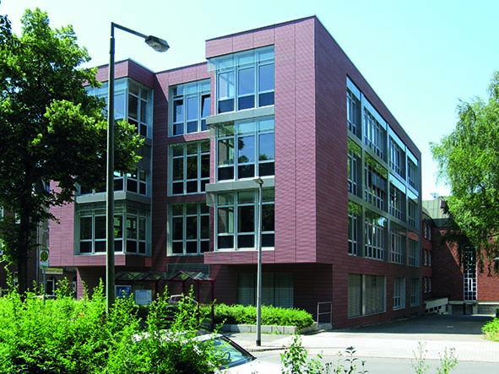

© Fraunhofer IMS
The Fraunhofer IMS in Duisburg.
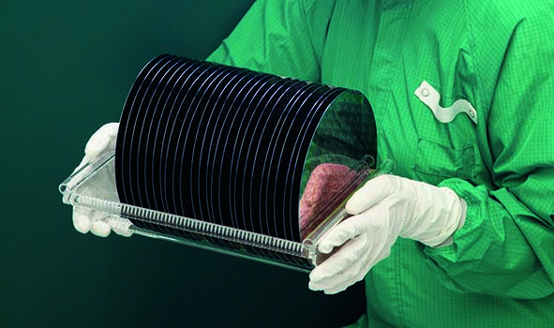

© Fraunhofer IMS
Wafer – that is what the mostly circular, about one millimeter thick disks of semiconductor blanks in the microelectronics are called. They serve as substrate for electronical complements and integrated circuits and are produced at Fraunhofer IMS Duisburg now since more than tree decades.

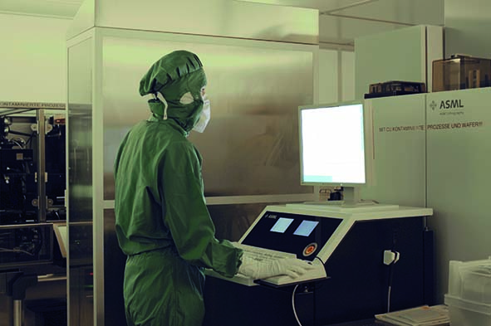
© Fraunhofer IMS
In the microsystem technology laboratory at Fraunhofer IMS a post-processing on a CMOS is implemented.
Dieses Feld, sowie die Tabelle auf der letzten Seite nicht löschen!

